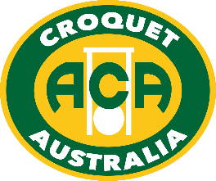

Australian Golf Croquet Women’s & Men’s Singles
Ever played in a National Golf Croquet Tournament?
Saturday 10 – Tuesday 13 September is your opportunity!
Go to Adelaide – Go Play!
Each year the Men’s and Women’s Australian Championships are held concurrently,
hosted by a different State, and South Australia has the honour in 2022.
Matches will be played at Croquet SA HQ, Hutt Road, Adelaide, and at Brighton, Glenunga, Hyde Park, Millswood, North Adelaide, Norwood and South Terrace Clubs. Venues each day have not been set, and will depend on entries, but are likely to rotate between all venues for both Women’s & Men’s events.
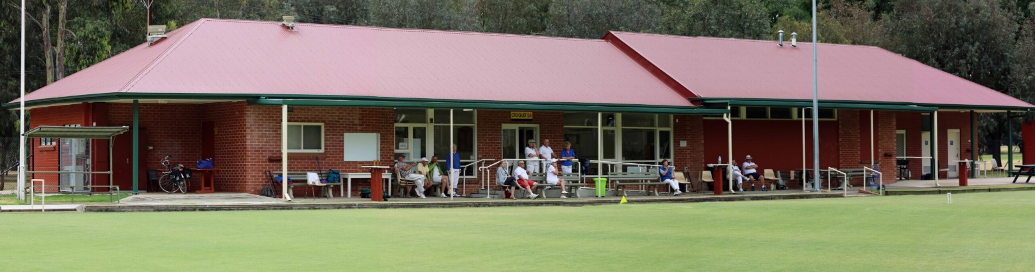
These events follow the Gold & Silver Medals (being held at Hutt Rd on 7-9 Sept)
and lead into the InterState Shield (Hutt Rd, North Adelaide & Norwood on 14-18 Sept).
If you have a GC handicap of 8 or better you should consider entering these events! Over the four-day period, entrants will compete in seeded blocks (single 13-point games) and then – depending on numbers –the top 16 (or 32) move into a knockout playing best of three.
The rest of the field then play in the Plate - if you would like to ‘have a go’ but are ‘not quite sure’ then just enter the Plate. Soak up the atmosphere, and watch Australia’s leading players as they get to the pointy end of the competition. Will Alison Sharpe and Owen Dickinson defend their 2019 titles?
(covid has prevented these events from being played since)
Entering is easy - just go to Croquet Australia’s website, click on Tournaments and then either GC Men’s Singles or GC Women’s Singles. Complete the on-line entry form, pay $90 and then keep an eye on Entries under these events on croquetscores. You can also just enter the Plate instead for $45.
Please enter by cob Friday 19 August 2022 (midnight WA time)!
ACA will make a call on 1 August re whether covid-19 prevents these events from proceeding.

If confused/have a query, email Peter Freer, Chair, ACA Events, events@croquet-australia.com.au.
Please note that Atkins Quadway hoops will be used, set to 3+¹¹/₁₆” for the block rounds.

SACA also requires at least double vaccination to play at Hutt Rd & other venues.
Proof / exemption required at registration

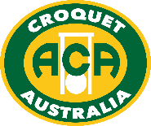

Australian Golf Croquet
Men’s and Women’s Singles
Saturday 10 – Tuesday 13 September 2022

Tournament Manager: Eileen Ferguson
Deputy Tournament Manager: Peter Martyniuk
Tournament Referee: Judy Stewart
Tournament Handicapper Peter Freer
ACA Events Peter Freer
Headquarters: SACA, Hutt Rd (Adelaide)
How to Enter: via ACA website: https://croquet-australia.com.au/gc-mens-singles/
or https://croquet-australia.com.au/gc-womens-singles/
Closing Date for Entries: Friday 19 August (by midnight WA time)
Entry Fees: $90 per player. If entering the Plate ONLY: $45 per player
Full time students (under 25) and players aged under 21 at December 2022 are entitled to 50% reduction of the above fees.
Prizes: The Winner of the Men’s Singles receives a gold medal and the ‘Sauce Bottle’. The Winner of the Women’s Singles receives a gold medal and the Cup. Runners-Up receive a silver medal each; and certificates are awarded for Third, Fourth Place and Winners of W, Z, Y and Plate.
Draw: To be conducted by the ACA Events Committee with help from the GC Selection Committee, using the ACA Seeding and Draw procedures. Seeding will use the latest available World GC Ranking list.
Registration: At SACA from 2pm on Friday 9 Sept. All Clubs open for practice from 1-4pm (SACA available after conclusion of Gold+Silver Medals).
Format: Depending on actual entries, play may commence with seeded blocks (single 13-point games) then 16 or 32 players to qualify for re-seeded XYZ draw (knockout, best of 3 games).
The Plate event will be designed to maximise the amount of play and will also depend on actual numbers, either in blocks or as a Swiss event. Players may enter the Plate events as follows:
  - players who are reserves or not allocated a place in the main event,
  - players entering the Plate Event directly (not through the main event).
Catering: Coffee & tea free; lunch & other food available for purchase.
Functions: Friday 9 Sept – 6-00pm Gourmet 2 course BBQ meal ($25 pp) at SACA, Hutt Rd. Drinks available for purchase. Gold, Silver and Bronze Medals presented.
Tuesday 13 Sept – “Welcome to South Australia” function to be held at the Unley Park Sports Club, Northgate St, Unley Park. This event will include presentation of Women’s and Men’s Singles Championship Medals and introduction of ISS Teams. This event is by invitation. Team photos will be taken at this event.
Sunday 18 Sept – Tournament Dinner at the Rydges Skyline Restaurant, 1 South Terrace Adelaide (6pm for 6:30pm). Cost is $75 per head. Presentation of the InterState Shield & medals.

www.croquet-australia.com.au

